PRACTICAL -11B

Code(11B):
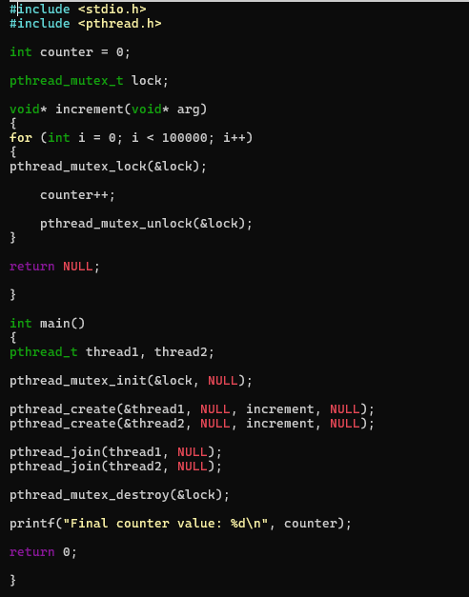

OUTPUT:
